# Popular Attacks

 [Refer Here](https://www.checkpoint.com/cyber-hub/cyber-security/what-is-ddos/) for DDOS atacks  CSRF [Refer Here](https://portswigger.net/web-security/csrf)

 SQL Injection

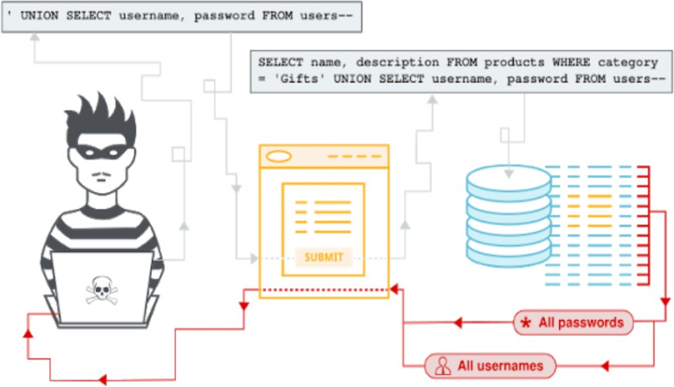

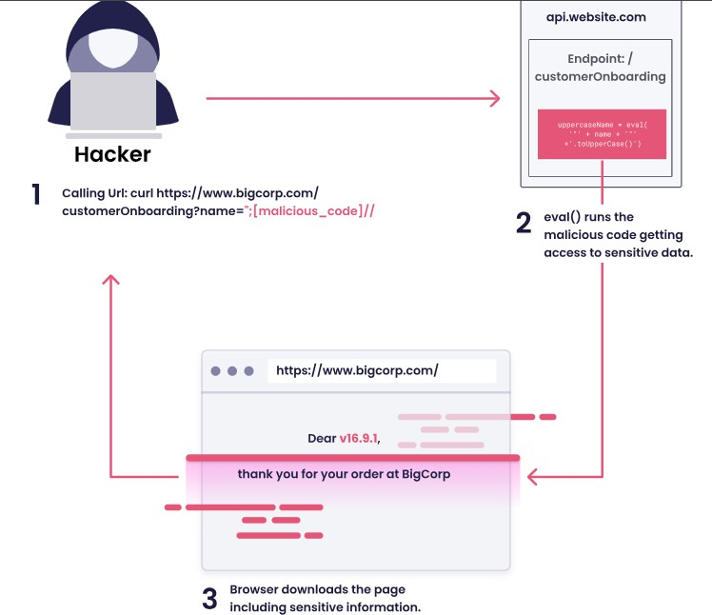 Javascript Injection

 Many more refer OWASP

# Firewalls in AWS

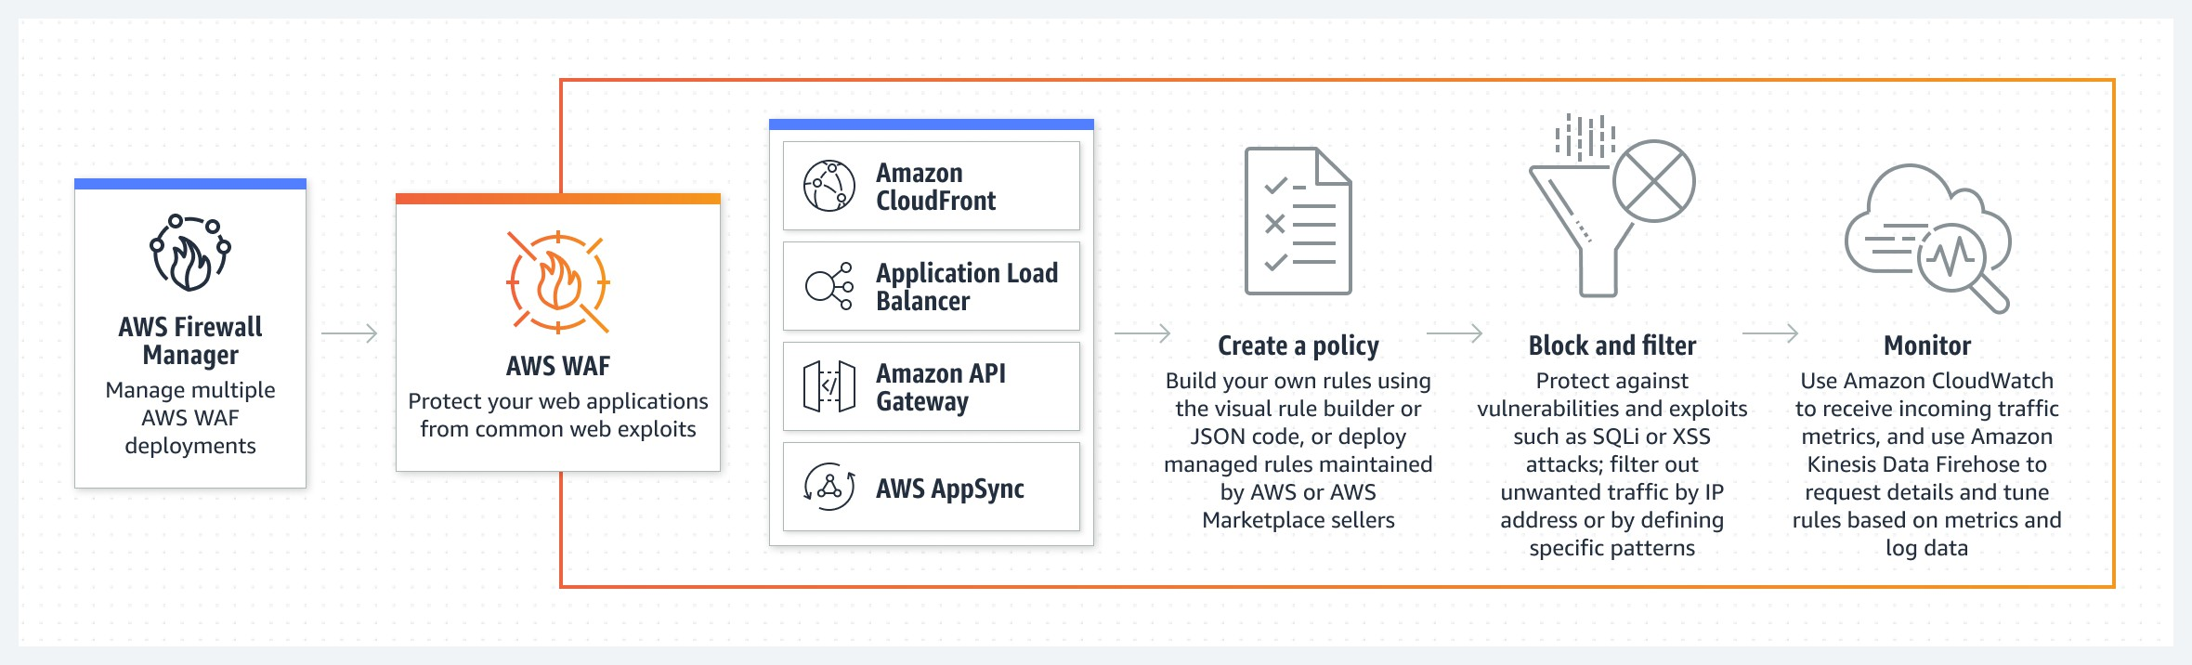 Web Application Firewall (WAF): This can be attached to API Gateway, Application Load Balancer

 Firewall Manager [Refer Here](https://docs.aws.amazon.com/waf/latest/developerguide/fms-chapter.html)

# Firewalls in Azure

 Web Application Firewall (WAF) [Refer Here](https://learn.microsoft.com/en-us/azure/web-application-firewall/overview)  Azure Firewall Manager [Refer Here](https://learn.microsoft.com/en-us/azure/firewall-manager/overview)

## Activities in AWS

 Create a vpc

 create a security group to allow only ping

 create a ec2 instance in public subnet with the above security group

 Also create an ec2 instance in private subnet with the differnt security group with same rules  now try to access http:// (this will not work)

 now try ping public ip this will work  VPC Flow Logs: [Refer Here](https://docs.aws.amazon.com/vpc/latest/userguide/flow-logs.html)

 Lets publish the vpc flow logs to s3 bucket [Refer Here](https://docs.aws.amazon.com/vpc/latest/userguide/flow-logs-s3-path.html)

## Activities in Azure

 Create a Vnet

 create a network security group to allow only ping

 create a vm subnet (with public) with the above network security group

 Also create an vm without public ip with the differnt security group with same rules as above  now try to access http:// (this will not work)

 now try ping public ip this will work

 Equivalent of VPC Flow logs of AWS is Network Watcher in Azure [Refer Here](https://learn.microsoft.com/en-us/azure/network-watcher/diagnose-vm-network-traffic-filtering-problem)